# Document Change Control

## Versioning

|  |  |  |
| --- | --- | --- |
| **Name** | **Date** | **Reason** |
| Corp. Change Ctrl Officer | 8/22/2018 | Initial Creation |
| Corp. Change Ctrl Officer | 1/20/2019 | Changes |
| Corp. Change Ctrl Officer | 1/31/2019 | Updates |

## Applicable Parties

This document is strictly confidential and should only be distributed or viewed by the following parties:

* HAL Designated Associates
* HAL Regional Employees (Compartmented to the Division)
* HAL Management Team
* HAL Auditing Team

## Review Period

This document is subject to review by the Information Security Policy Committee (ISPC) at a minimum interval of quarterly (every 3 months) at a maximum interval of bi-annually (every 6 months).

### Previous Reviews

|  |  |  |
| --- | --- | --- |
| **Committee** | **Review Date** | **Approval Date** |
| ISPC | 7/15/2018 | 8/1/2018 |
| CEO | 1/21/2019 | 1/21/2019 |
| Corporate CIO | 1/23/2019 | 1/23/2019 |

# Purpose

The purpose of this procedure is to provide guidance to all members of the HAL organization on how to implement the HAL ISSP for Change Control.

# Scope

## Applicability

This procedure serves as a standard of performance and applies to all HAL employees and affiliates at all HAL facilities and locations world-wide.

## Ownership

This procedure is under the direct control of the HAL Corporate CIO with input from the corporate change control manager and other members of management with an interest in the program.

This procedure is promulgated by the HAL Change Control Committee (hereafter CCC) as defined in the HAL ISSP for Change Control.

# Change Request Process

## Types of Change

The types of change and how they are reported is defined in the HAL ISSP for Change Control.

## Change Journal

The official record of change is the Change Journal. All change, regardless of type or declaration of a period of rapid change, will be entered into the Change Journal. No change is authorized in any circumstance unless it is entered into the journal. Each entry in the change journal must be completed prior to or at the same time as the preparation of a Change Request Form (if one is required) or the implementation of any change that does not require the use if such a form.

### Completing the Journal

Carefully read and follow the directions embedded in the Change Journal as to how to complete all of the fields found in the Change Journal.

Note that a separate journal worksheet (Excel tab) will be kept for each system that is used by HAL. This includes any server or desktop computer system as well as appliances that make use of a general operating system that HAL employees have administrative control over.

In this context a “journal” is the individual form maintained for each system, and not a physical binder. There is a single Change Journal Binder used to store and manage hard copy Change Journals, which should be kept up-to-date, as it is subject to random inspection by corporate auditors.

## Change Request Form Completion

All business before the CCC to seek approval will be accomplished using the HAL Change Request Form excepting changes that were made during declared periods of rapid (emergency) change, which only require reporting using the Change Journal. All change requests will be recorded and submitted for approval using this form except for provisions noted in the ISSP regarding periods of rapid change. Changes without forms, made in such periods, will be recorded in the proper Change Journal kept for each system.

When necessary, the Change Request Form shall be completely filled out with exception to the fields specifically designated for ‘Management Approval’. A separate Change Request Form must be submitted for each server and for each set of changes to each server. Once a form is submitted, any subsequent changes must be submitted in a new form.

For all non-emergency change, the roll back portion of the form must be addressed properly and completely. If a roll back plan is deemed unnecessary for the change, provide a business-driven statement as to the particulars in place of the plan. If not completed, the request will face likely rejection.

### Change Control Number

Each regional office will assign change control numbers to all change requests (regular or emergency). This change control number must accompany all reporting and logging events regarding the matter of interest throughout all process implementation and reporting stages.

Create the number as follows:

* The prefix “CCN”
* A dash
* Your region (Team) number or letter designation as assigned.
* A dash
* The letter “R” if this is routine change that will appear on the agenda of the CCC for prior approval, or the letter “E” if this is either an emergency change or a change made in a declared period of rapid change
* A dash
* A sequence number assigned by your region starting with the number 1000 and incrementing by one as changes are generated. Use only one sequence for both routine and emergency change.

For example, a valid change control number might look like “CCN-J-E-1001” or   
“CCN-36-R-1002”

### Location

The change request form template and the template for the change journal shall be made available to all employees expected to need them in the course of their assigned duties.

### Format

The Change Request Form, when submitted via electronic means, shall always be submitted as a .PDF file type. The change journals, when submitted via electronic means, will always be submitted as separate spreadsheet format files, with the content of each system’s change record as either a separate workbook, or each system reported as a separate worksheet within a single workbook for the region or division.

### Completing the Form

Carefully read and follow the directions embedded in the forms and templates as to how to complete all of the fields found on the Change Control Request Form and the rows and tables of the Change journal. Such instructions, when found in the current version of the template files, supersedes instructions found elsewhere in procedure level documentation.

## Form Scope

### Multiple Changes, Same Category

If multiple changes for the same category of changes are required, a single change request number shall suffice as proper documentation of a requested change. Except in declared periods of rapid change, every change request number will be reported on a separate change request form and will occupy one row on the change journal. For example, if multiple firewall rules are required, these can be submitted within a single change request provided they are all documented.

### Multiple Changes, Different Category

Changes across multiple categories shall not be submitted in a single document. For example, if multiple firewall rules are required along with an access authorization requirement, these two categorical changes must be submitted in separate change requests.

### Same Change across Identical or Similar Systems

If the same change is being made across multiple identical or similar systems, a single change request form submission shall suffice as proper documentation of a requested change. For example, if an identical user with identical rights is being added across systems with identical or similar architecture, these changes can be submitted within a single change request provided they are all documented.

### Same Change across Diverse or Different Systems

If the same change is being made across multiple diverse or different systems, these changes shall not be submitted in a single change request. For example, if a user is being added across systems with diverse or different architecture, these changes must be submitted in separate change requests.

## Request Submission

### Request Submittal

All change requests submitted for review and/or approval shall be hand-carried to the CCC meeting for consideration in the ad hoc portion of the agenda PRIOR TO the initiation of any systems modifications. Emergency Change Requests should be filed at the first meeting after the emergency change as possible. The Change Control Manager will not approve incomplete or inaccurate documents, further delaying any needed changes.

### Submittal Deadline

The submittal deadline for all change control requests to be considered the start of the next scheduled meeting. Any change requests delivered after the start of the meeting shall be considered late and subject to penalty.

## Emergency Change Control

In the event that an emergency change is required, required paperwork must be completed and submitted to the Change Control Manager at the next CCC meeting.

# Agenda Requests

## Approval

If all reporting requirements are met, each change request will be reviewed at the next CCC meeting.

## Denial

If any of the reporting requirements are not successfully met, the change request shall be summarily denied.

# Change Control Meeting Date and Time

The Change Control Meeting shall take place at the times and places announced by the Change Control Manager in consultation with the corporate CIO and other interested parties.

# Meeting Requirements

## Hard-Copy

A single hard-copy of all pending or proposed requests is required for all matters. Similarly, all offices must bring updated and correct copies of all change journals, with special attention to those containing emergency change actions. These will be reviewed by the CC Manager, and any deficiencies reported to Corporate.

All CCOs must arrive on time for all meetings, with complete copies of all required documentation, prepared to discuss any change requests and any past changes under emergency actions. Failure to arrive on time, or with appropriate documentation will result in punitive measures as per HAL policy.

# Process Flows

## Assessing Change

Figure 1 shows the process of determining Change Case type.

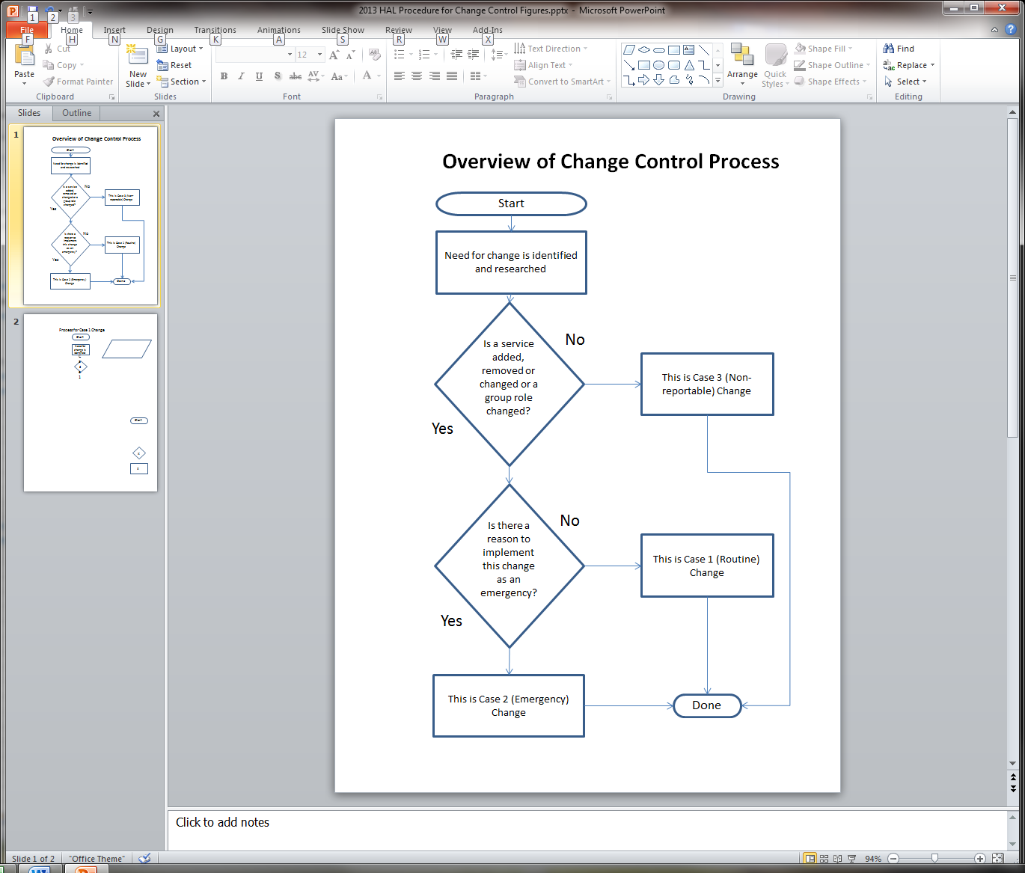

## Routine Change

Figure 2 shows the process for Case 1 (Routine) Change.

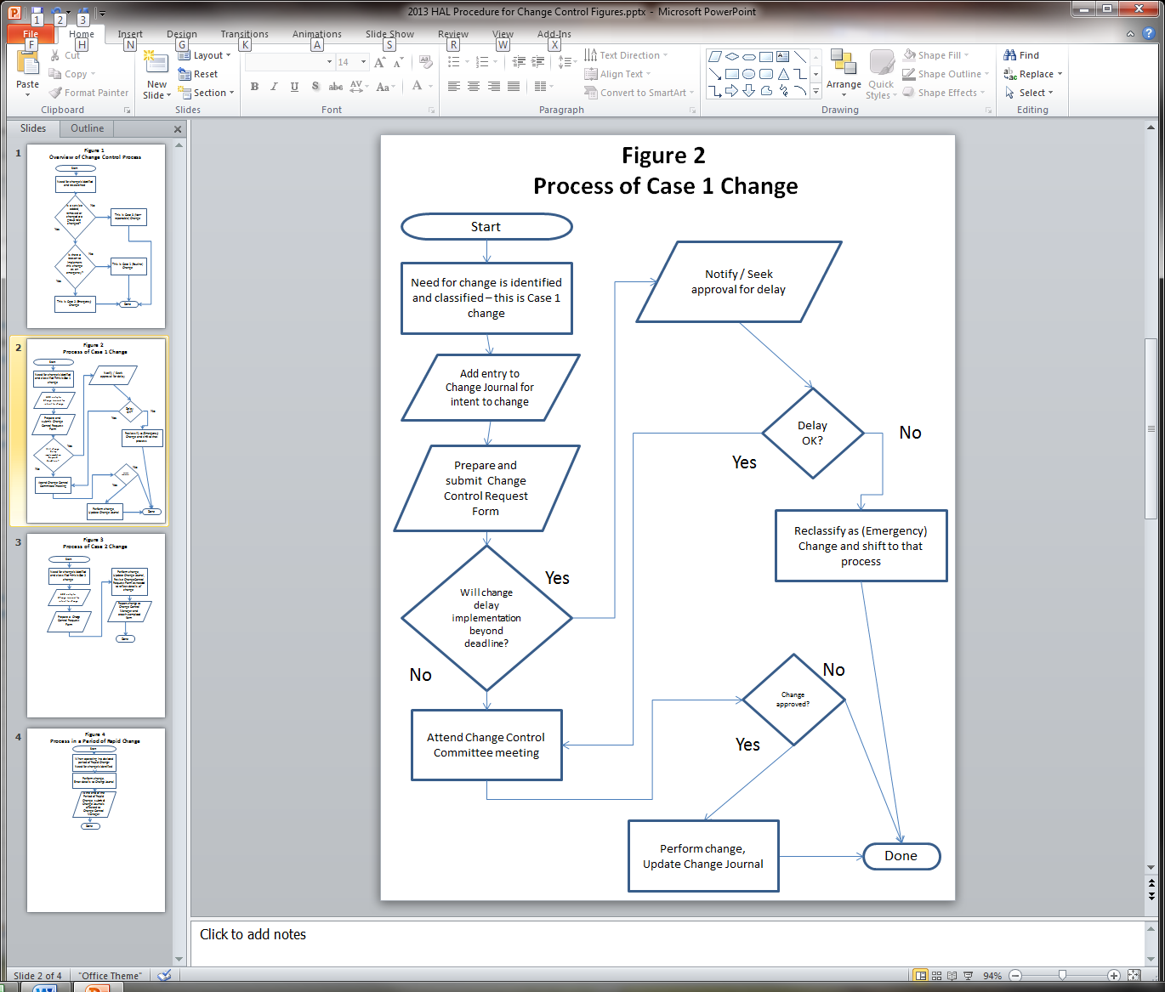

## Emergency Change

Figure 3 shows the process for Case 2 (Emergency) Change.

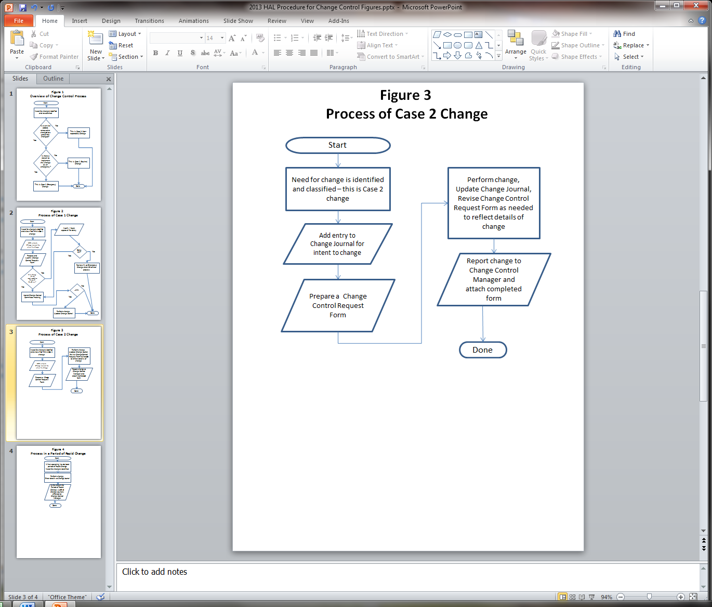

## Period of Rapid Change

Figure 4 shows the process which should be employed when periods of rapid change are declared for some or all units of HAL.

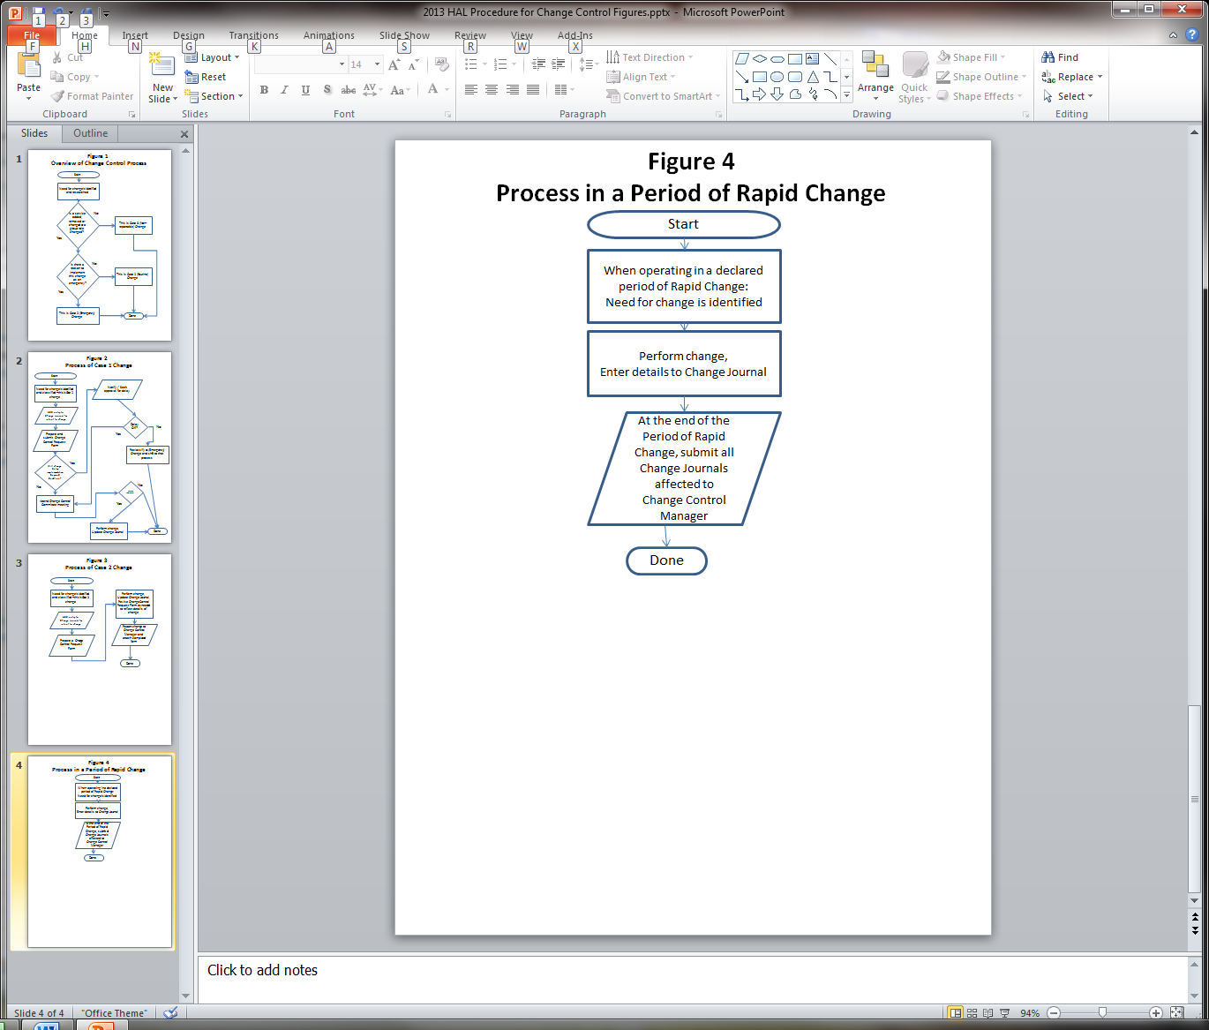

# Enforcement

Any employee found to be in violation this policy may be subject to disciplinary action, up to and including termination of employment.

*NOTE: As part of the SECCDC event some injections have point assessment for Change Control actions and some infractions of the rules regarding CCC process may result in a point penalty.*

*Point penalties guidelines*

*Penalties will be assessed for the following infractions, per occurrence:*

* *Minor infractions such as improper form completion or failure to properly submit forms (after a warning)*
* *Failure to submit emergency change notices properly and in a timely fashion*
* *Failure to classify a routine vs. emergency change properly (specifically decisions to classify obvious routine changes as emergency changes)*